STATISTICAL METHODS IN EPIDEMIOLOGY

SESSION 12 PRACTICAL

R Version

You will need to have watched the session 12 lecture before doing this practical.

Objectives

By the end of this practical, students will be able to:

- use logistic regression with quantitative exposures, and test whether fitting these exposures as quantitative rather than as categorical variables is appropriate;
- interpret R output from a logistic regression model with a quantitative exposure.

Tasks and Questions:

Note:

The underlined portions are questions for you to consider and answer throughout the practical

- This indicates an action to take in R

…and these are notes to help with that action. If something is bold it is a variable, function, or parameter in R

This is the 3rd practical where we have asked you to write your own script, we are going to exclude instructions we expect you to know to do, such as importing data. Refer to practical 10 and 11 if you need a reminder.

The practical will need the following packages: haven, tidyverse, gtsummary, lmtest, marginaleffects (optional: here)

- Using data set mortality.dta investigate the association between systolic blood pressure and risk of death. In particular we would like to investigate if there is linear dose response between systolic blood pressure and log odds of death.

A normal systolic blood pressure is below 120; pre-hypertension is defined as a value between 120 to 139 and hypertension ( or high blood pressure) is defined as 140 or higher.
  - First, explore the data plot of systolic blood pressure (systolic) on the x-axis against the outcome (y-axis) of death.
Plotting in R can be done using ggplot() which is part of the tidyverse. ggplot() does not use standard piping ( |> ) and instead used a + to add elements to the plot. The other significant difference in ggplot() is how the x and y axis are defined:
data |>
ggplot(aes(x = varaible1, y = variable2)) +
and how the plot type is defined:
geom_point() #this is a scatter plot
if you type geom_ into R you will see a dropdown of all of the plot types

If you want to change the look of the plot try one of the theme_ () functions
The labels can be improved with labs(title= , x= , y= )

What type of plot best represents the data?
What does the plot show you?
Can you identify the relationship between systolic blood pressure and death?
  - Now group systolic blood pressure into three levels (defined above)
Remember to define a new variable using mutate() and cut()

  - Make a 2 x 2 table of systolic blood pressure-grouped against “died”; add appropriate percentages.
use tbl_cross()

Write down a sentence describing the relationship between systolic blood pressure-grouped and death based on this summary

  - Explore the association of systolic blood pressure and death
The tabodds() function calculates ORs for each level versus the reference group and provides a score test for trend. This is part of the mh_functions.R

  - Plot the log(odds) of death by systolic blood pressure-grouped on the graph below.
Normal = 1,Pre-hypertension =2, Hypertension = 3
  - Draw a straight line ‘by eye’ through the points you have plotted and estimate how much the log(odds) of death change for an increase in one unit of systolic blood pressure-grouped.

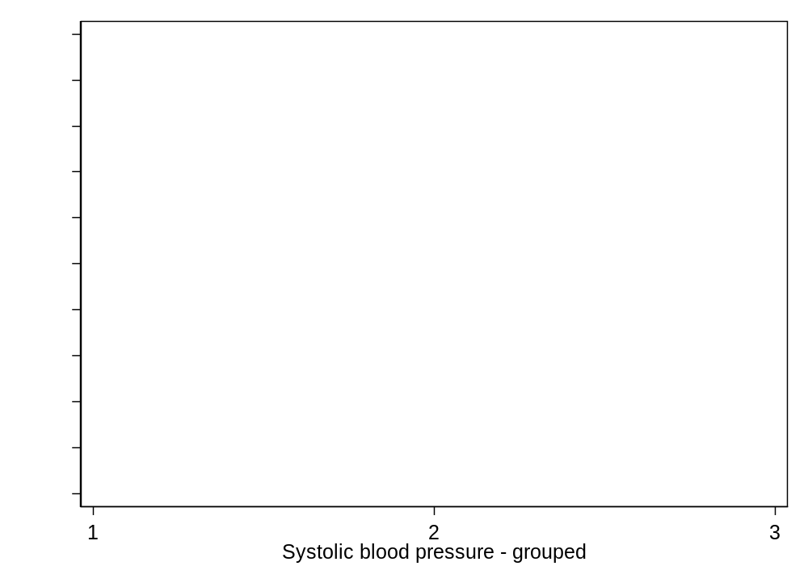

  - Now fit a logistic regression model for death with the exposure being systolic blood pressure-grouped reclassified into a continuous variable (1-3) obtaining your output on the log(odds) scale.
Use as.numeric() to reclassify blood pressure. Make a new variable
Use glm() and summary() to view the results in log space.

What is the value of the slope of this regression line?
What is the meaning of this slope?
How does its value compare to your answer above?
What is the interpretation of the estimate of log(odds) for systolic blood pressure-grouped?
  - View the results in odds space.
tbl_regression()

What is the interpretation of the odds estimate for systolic blood pressure-grouped?

  - Fit a model with systolic blood pressure-grouped, assuming factors (categorical)

  - and perform a likelihood ratio test of the null hypothesis that the effect of systolic blood pressure-grouped on the log(odds) of death is linear (continuous regression) versus the alternative that the relationship is more complicated than linear (categorical regression).
Use lrtest()

Write down 2-3 sentences summarising your findings

  - Recode the levels of systolic blood pressure-grouped (1, 2 and 3) to now reflect the mid-point (or some average value) for each interval and fit the same continuous model. We recommend 110, 130, 150.
For this you will use mutate() as.numeric() and case_when()
What is the interpretation of the estimate for systolic blood pressure-grouped?

- Again using mortality.dta, this time is we will focus on outcome = death, exposure = visual impairment, confounder = age

  - Check and transform data as needed. We want to consider age as a continuous and categorical variable
  - Fit the continuous and categorical models

If we treat age as a confounding variable, does our estimate of the effect of visual impairment differ when the confounding variable is treated as a linear effect rather than a categorical one? Compare this model with one where agegrp is categorical (i.agegrp). ∫

b) (optional — see supplementary material in the lecture notes)
- Perform an LRT for effect modification between vimp and agegrp treated as continuous.
Remember that effect modification is defined by *

Is there evidence that the association of visual impairment on death differs by age group, where age group is treated as a linear effect?

3. Using the Mwanza data set (MWANZA.dta), investigate the association between HIV infection and number of injections in the past year. Remember that the zero group should be excluded in order to confirm that a trend with increasing numbers is not simply induced by a difference between the zero category and the rest. See section 9 of lecture notes and Clayton & Hills pp 256-258 for more on this.

